Architecture package

- Context View

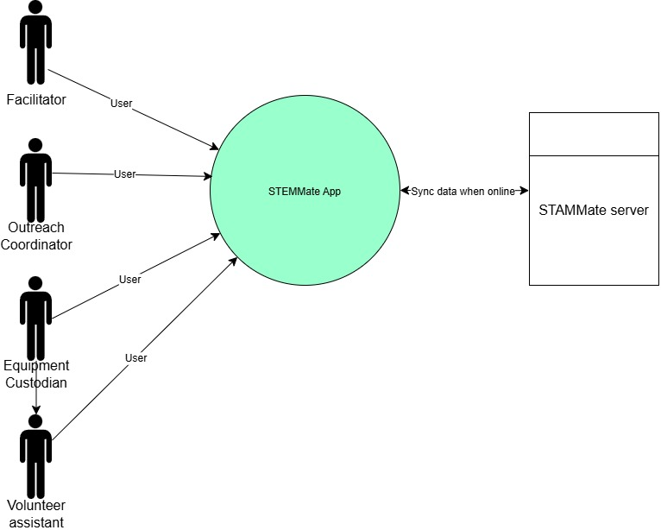
Figure 1 – Context diagram

- Container and component view

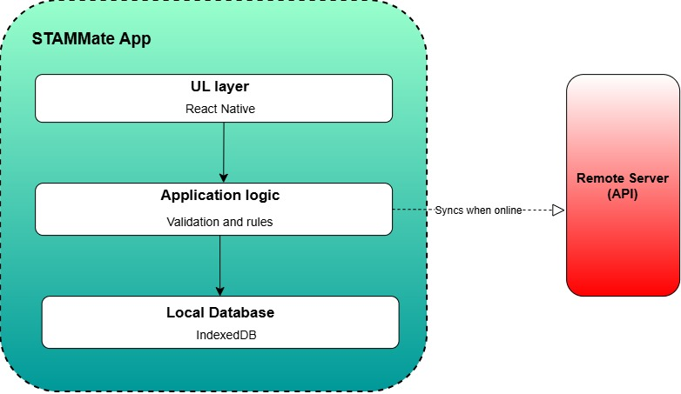

Figure2 – STEMMate container diagram showing UI, application logic, local database and sync service.

- Deployment View

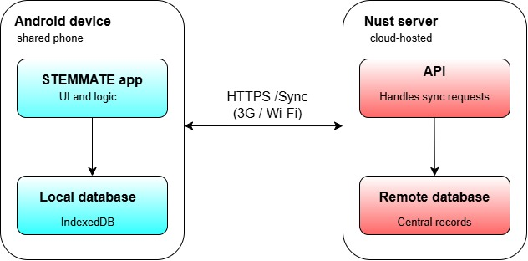
Figure 3- Deployment diagram showing the shared Android device and cloud server.

- UML
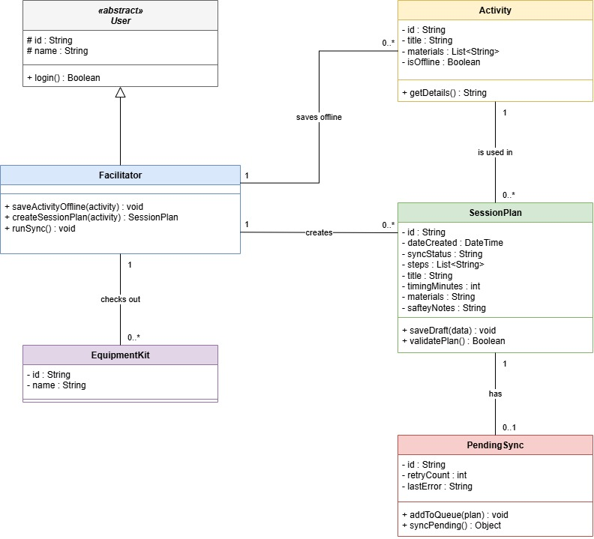
Figure 4- STEMMate UML diagram

- Logical Data Model
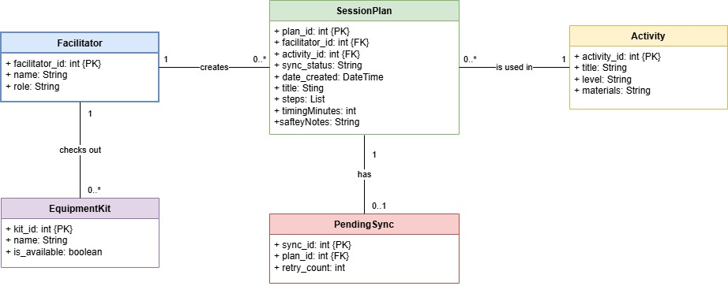
Figure 5- Logical data model for database

- Role/Access rules
User Role | Permissions | Privacy constraints
Facilitator | Create session plans, save offline, sync data and search activities. | Cannot view other facilitator’s drafts.
Outreach coordinator | Read-only access to synced session plans and broad participation reports. | No access to pupil names.
Equipment Custodian | View kit availability and update status. | Cannot view session plan contents.
Volunteer Assistant | Read-only access to session plans. | Cannot edit session plan or sync data.

- Offline/synchronisation
  - Local-First Saving: When a plan is created or edited the app saves it to the local IndexedDB database and does not nee to wait for the internet.
  - The Queue: sync_status is set to Pending and the record is added to the PendingSync table if the is no internet connectivity.
  - Background Sync: The app check for internet periodically. If there is internet, pending plans are pushed to the server.

- Architecture Decision Records (ARDs)

ARD 01: Local-First Database
Facilitators must be able to browse activities and draft session plans offline. To do this the database needs to be local.
Options
- Remote Cloud Database: Requires constant internet access. This fails the offline requirement.
- Browser LocalStorage: JSON is easy to implement but it is prone to data corruption.
- IndexedDB: A built-in browser database that uses structured data and supports transactions.
Decision
We will implement SQLite for our local database on the user’s device.
Trade-off
Reliable offline data persistence but, we will have to deal with complexity in the development like writing schemas and migration.

ARD 02: Offline synchronisation
Data created offline must be sent to the server without data loss.
Options
- Real-time sync: Attempt to sync every element to the server. Data will fail to sync in low-connectivity areas.
- Manual export: User exports a JSON file and emails it.
- Queue-based background sync: Data is saved locally and the app queues the sync. When there is internet connectivity, it pushes the queue.
Decision
We will use Queue-based background sync with the PendingSync table in the local IndexedDB database.
Trade-off
Users will not lose their work when the internet drops before saving. We will however have to handle sync conflicts.

ARD 03: UI framework and Accessibility Constraints
STEAMMate must be accessible on shared, low-spec devices. The interface must be legible with clear status indicators.
Options
- Custom Native Android: Kotlin has high performance but requires high development time.
- JavaScript Framework: Fast to develop but due to large bundle size it will not thrive on low-spec devices.
- HTML/CSS/JS: It is lightweight and runs instantly in any browser, easy to enforce global accessibility themes.
Decision
We will build the vertical slice using HTML, CSS and JavaScript. With global CC variables we will enforce WCAG 2.2 AA compliance like high-contrast deep green and cream as well as non-colour cues.
Trade-off It is fast on low-spec devices and works offline in the browser via IndexedDB. However, we must write more custom UI code rather than using pre-built components from a framework.

